

Extension of Tulare Lake Subbasin Groundwater Extraction Reporting Period and Reporting Deadlines Under SGMA

Actions related to the Tulare Lake probationary designation were suspended by a preliminary injunction starting September 13, 2024. On October 29, 2025, the Fifth District Court of Appeal issued a decision reversing the injunction. Groundwater pumpers in the Tulare Lake subbasin should plan to submit initial extraction reports to the State Water Resources Control Board (State Water Board) by the deadlines outlined below, unless they are exempt.

More information regarding what the Fifth District’s ruling means for groundwater pumpers in the Tulare Lake subbasin will be available on the Board’s Tulare Lake Subbasin webpage on or after November 3, 2025.

New Extended Reporting Period and Deadline
The State Water Board combined two reporting periods and extended the deadline for the first groundwater extraction reports in the Tulare Lake Subbasin required under the Sustainable Groundwater Management Act (SGMA).
- Reporting Period: July 15, 2024, through September 30, 2025
- Reporting Deadline for Reporting Period above: May 1, 2026
- Reporting Deadline for Subsequent Reports: February 1 following the reporting period.

Invoices for extraction fees will be mailed to pumpers after the reporting deadline. Small domestic (household) well users who extract two acre-feet or less of groundwater per year for domestic purposes only are considered de minimis users and are exempt from reporting and paying fees.

The Tulare Lake Subbasin was designated as probationary on April 16, 2024, under State Water Board Resolution No. 2024-0012. This extension is authorized by the State Water Board’s Executive Director and will take effect 30 days after the date of the notice, consistent with the resolution.

The State Water Board will confirm the new reporting timeline via U.S. mail to Tulare Lake Subbasin groundwater sustainability agencies and known groundwater extractors that may be impacted by the changes noted above.

Questions?
Please contact the SGMA Program at sgma@waterboards.ca.gov
For more background information, visit the Board’s Tulare Lake Subbasin webpage
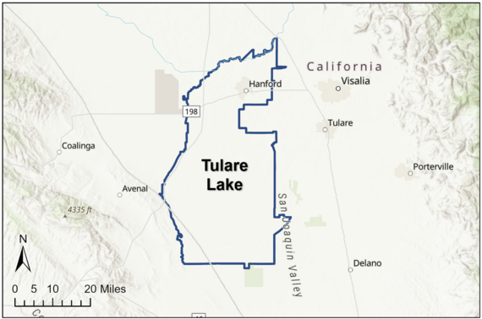
Map of the Tulare Lake Groundwater Subbasin

