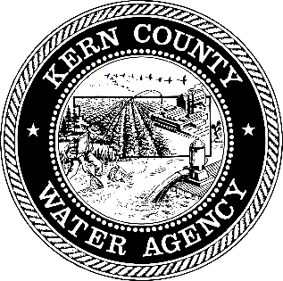
FOR FURTHER INFORMATION CONTACT:
Tracy Leach (661) 703-5639
January 28, 2026
For Immediate Release

Kern County Water Agency Statement Regarding Western Hills Water District

Over the past six years, the Kern County Water Agency (Agency) has undertaken extensive and sustained efforts to work with Western Hills Water District (Western Hills) to address the Western Hills’ water supply and financial challenges.

Over the past year, the Agency participated in multiple meetings and negotiations aimed at identifying feasible solutions that would allow continued water deliveries while recognizing Western Hills’ financial circumstances. As part of these efforts, the Agency proposed modifying water purchase volumes to better align with the Western Hills’ actual community demand.

In addition, and in recognition of Western Hills’ financial condition, the Agency proposed certain financial adjustments in an attempt to significantly reduce Western Hills’ outstanding $14M financial obligation to the Agency.

Despite these proposed adjustments, Western Hills has declined the Agency’s proposals and has instead requested the Agency accept payments at levels substantially below the Agency’s actual cost of the water to be delivered.

As noted by Gene Lundquist, a member of the Kern County Water Agency Board of Directors:

“We recently read how Western Hills issued shut-off notices to certain residents for non-payment after 60 days and indicated they were following state law in doing so. They are over six years behind on payments to the Agency and we have a fiduciary responsibility to those we represent. We are no longer able to provide water at no cost and must act to protect the interests of our constituents in Kern County.”

The Agency cannot agree to arrangements that would require the Agency to deliver water at a loss or shift financial burdens to other public agencies and ratepayers.

The Agency has made good-faith efforts to balance flexibility with fiscal responsibility and has attempted to develop solutions with Western Hills. Western Hills is over six years behind in payments and has received water at no cost over that period, with catch-up payments starting only a few months ago. The Agency must take action to protect the interest of its constituents and can no longer subsidize the water supply for Western Hills.

###

The Kern County Water Agency (Agency) was created in 1961 by a special act of the State Legislature and serves as the local contracting entity for the State Water Project. The Agency, which celebrated its 50th anniversary in 2011, participates in a wide scope of management activities, including water quality, flood control and groundwater operations to preserve and enhance Kern County’s water supply—the main ingredient for the well-being of an economy.

